# Areas of interest

### Variable payoff matrices

* Payoff ∝ f(Ri, Rj) for some function f(x) where Rx represents the reputation of some agent *x*.

### Ability for agents to refuse to interact with other agents

* The probability that agent *i* will interact with agent *j* is proportional to some function of the reputation of the other.

### Spatial Prisoner’s Dilemma game in finite populations implementing existing strategies

* Utilising a probabilistic model to determine movement in contrast to the existing uniform probability of movement in any given direction.

### Agent-specific reputation tracking

* The reputation of each agent in a population (spatially or not) is known globally under the assumption that within smaller populations an assigned reputation is “widely and faithfully disseminated throughout the population” (Santos, Santos & Pacheco, 2016).  
  However in larger populations, I propose that each agent records the reputation of agents with which surrounding agents have interacted. This is in essence a simplified model for gossip in both small and large populations.   
  For small populations, this model should produce similar results to that in which reputation is known globally.
* A simple example of this idea is based on the model for the spatial prisoner’s dilemma game

## Misc

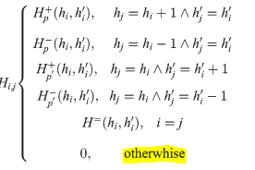** Spelling error in Santos, Santos, Pacheco